Guidebook for
New Course and Outline Revision Approval

Revised November 2015
Clackamas Community College Curriculum Committee

Table of Contents
Introduction 1
Who should read this guidebook 1
Faculty course outline revisers or creators 1
Department chairs, members of curriculum committee, and faculty-led review panels 1
How to use this Guidebook 1
Curriculum Committee: Gen Ed Approval Process Flow Chart 2
Course Outline Review Process for Department Chairs 5
Establishing the “Pipeline” 5
Course Outline Review Process for Editors/Reviewers 6
New Course Approval Request 6
Submit New Course Approval Request 6
View Existing Course Approval Request 6
Edit Course Approval Request 6
View Grandmasters 6
Course Approval Forms 7
New Course Approval Request form 7
Gen Ed Mapping Screen 10
Outcomes Assessment Strategies 11
Section #2 Course Transferability 12
Frequently Asked Questions 13
Why Course Outline Revision? 14
Key Course Outline Field Descriptions and Examples 14
Course Outline 15
Student Learning Outcomes 16
Length of Course 16
Grading Method 16
Prerequisites and Co-requisites 16
Major Topic Outline 17
General Education Mapping Field 18
Worksheet for Mapping General Education Outcomes 19

Writing Measureable Student Learning Outcomes 22
Identifying Student Learning Outcomes 22
Learning Domains 23
A Revision of Bloom’s Taxonomy of Educational Objectives 24
The Knowledge Dimension 24
The Cognitive Process Dimension 25
Evaluating Student Learning Outcomes 27
Student Learning Outcome Checklist 30
Worksheet for Student Learning Outcome Generation 31
Frequently Asked Questions 32

________________________________________________________________________________________________________________
Guidebook for New Course and Outline Revision Approval
__________________________________________________________________________________

Introduction
CCC initiated a new course approval and course outline revision (COR) process in the fall of 2012. A three-year timeline for outline revision was proposed by the ISP and then adopted by the Curriculum Committee. Most CCC courses, except Career Technical Supplemental, will be affected. The Curriculum Office will list precisely which courses from each department will be placed on the revision schedule, including the timeline for revising them. This guidebook will help faculty members successfully navigate this process. The Curriculum Committee will establish and coordinate the schedule, faculty-led review panels, new web-based application and computer interface.
This new process requires revisions less frequently than before and was made possible by the removal of the requirement that outlines include textbooks to be used in the course. There will be more work on fewer outlines per year. Changes will be reflected in the College Catalog, as well, and every other place where information from the user interface is sent.
Who should read this guidebook?
Faculty course outline revisers or creators
This guidebook is intended to teach course/ curriculum developers about aspects of the new course outline revision process and how to produce course outlines that will pass muster with the review panels and Curriculum Committee. Course outline developers should pay particular attention to the sections on developing measurable student learning outcomes (SLOs).
Department chairs, members of curriculum committee and faculty-led review panels
This guidebook will also serve as a reference manual for department chairs, the Curriculum Committee and faculty-led panels that will review the outlines. Panel participants will use the manual to verify that each outline component is included and meets the criteria put forth in the guidebook.
How to use this Guidebook?
This guidebook can be used to learn the COR process and the new web-based application and computer interface that has been created to facilitate the COR process.
- It guides the reader in determining details about the COR process, including timelines.
- It describes how to get access to the new course outline database and interface.
- It shows how to search for and access existing course outlines.
- It explains how to edit course outlines, including useful definitions and examples for each component of the course outline.
- It suggests procedures for review and approval of course outlines, including sample reviews and steps for troubleshooting a non-approved course outline.
Additional documents on the Curriculum Committee website can be found here:
http://www2.clackamas.edu/committees/cc

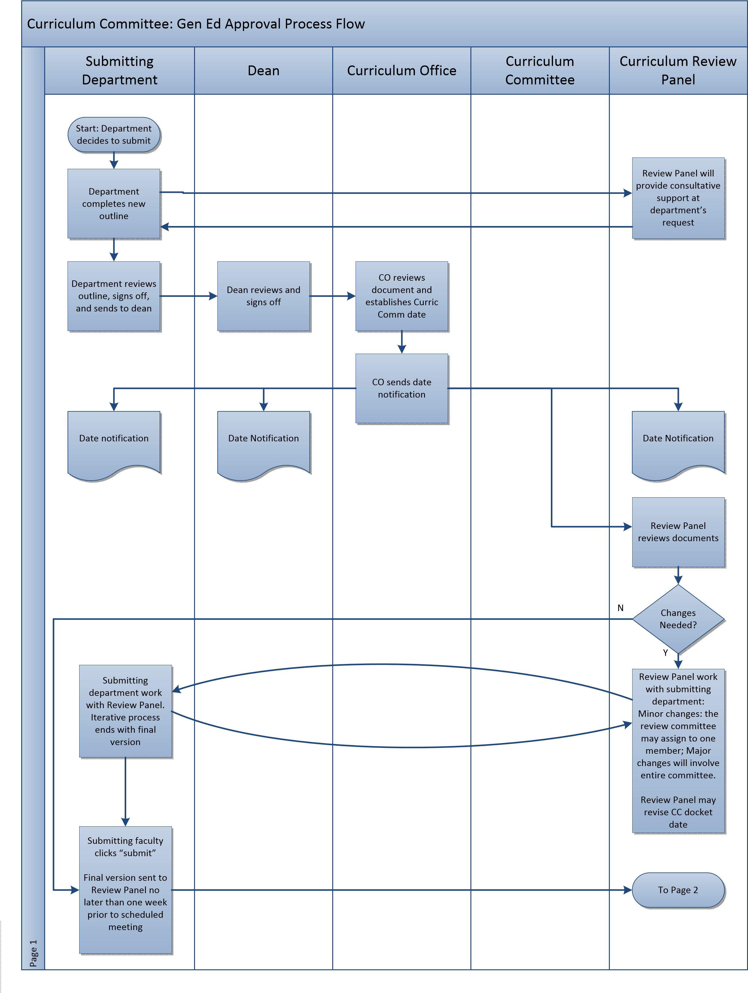
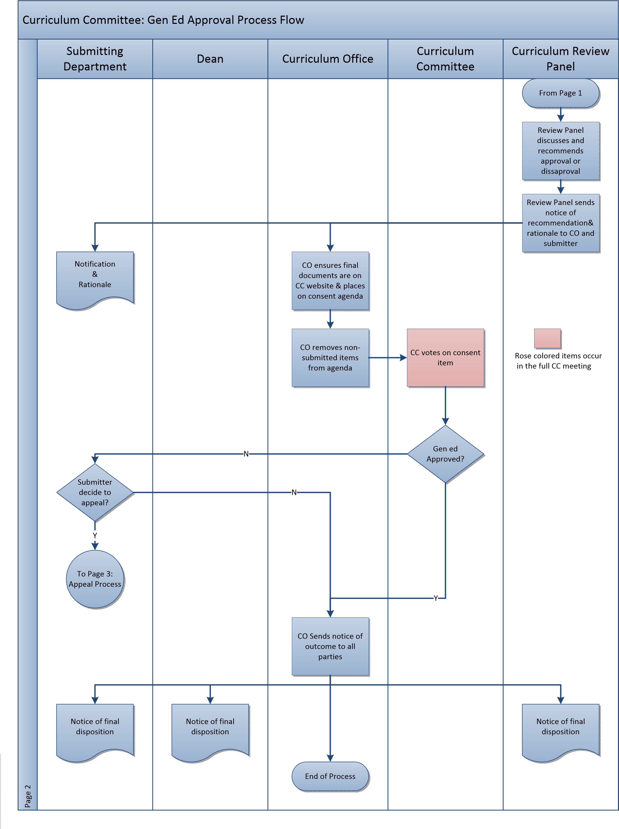
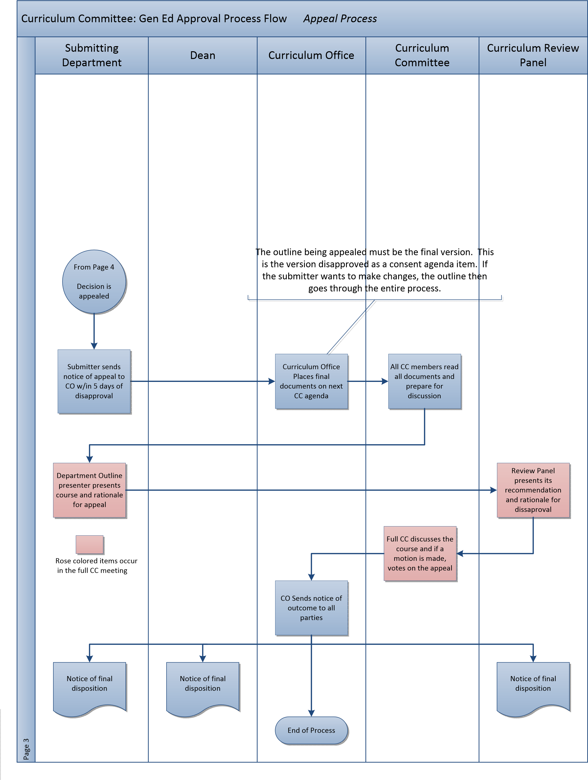

Course Outline Review Process for Department Chairs
Course outlines must be updated and, if necessary, revised, every three years instead of every year. These changes will be reviewed by the Curriculum Committee. However, the procedure for doing so has changed dramatically. This is a five-step process:
The Curriculum Committee will review up to 100 courses per month. These courses will be placed in a “pipeline” for processing. The Curriculum Specialist coordinates the “pipeline” of all currently-approved courses and will initiate the process. You should take the following actions once the Curriculum Specialist has contacted you.
Establishing the “Pipeline”
- Please divide the courses the Curriculum Specialist sends you into 3 groups of the same size. If they are not divisible by 3, assign the remainder(s) as you wish.
- Assign each third of your courses to an academic year in a three year cycle. Do this according to the order in which you, as a department, think they need revising.
- For courses assigned to the first academic year in the cycle, indicate the order in which you would like to revise the courses, taking the following into consideration:
- Any new courses that you plan to launch winter term of this year should be at the top of the list.
- New courses you plan to launch spring, summer, or next fall term can compete as equals with other courses you might revise.
- Based on what you read in this Guidebook, consider placing courses you consider “slam dunks” for approval near the top of your list. This will give you more time to do quality revisions of outlines that require more work and it will help the Curriculum Committee work out the bugs in its review process. The date of the most recent revision of an outline does not matter, so a recently-approved course could qualify as a “slam dunk”.
Before proceeding to step 4, review the information in this Guidebook.
- Send to the Curriculum Specialist, the 3-groups division and the prioritized first group by October 15 of each year. The Curriculum Office will distribute that first third across the six Curriculum Committee meetings which will be dedicated to reviewing outlines and let you know by what dates you should submit the respective outlines for Curriculum Committee.
- During Spring/Summer Term repeat steps 3-4 above for the second third of your outlines, etc.
As you probably know, the outlines will be submitted electronically. This will involve entering information into fields, a complete explanation of which you will find in this Guidebook. Please wait to begin actual outline revision until you are able to access your existing courses electronically. It is critical that you don’t use some other version you might have in some other file, because it might not be the most recent version.
Course Outline Review Process for Editors/Reviewers
Procedures to get access to the new course outline
database and interface:
Start up a web browser and navigate to the web applications tool at
You may want to bookmark
this link for future use
http://webappsrv.clackamas.edu/courserequest/Default.aspx
This will take you to the screen entitled
Online Course/Outline Submission System
Select the button that best fits your need:

Revise Course Outline – Use to find and edit existing course outlines. This guidebook is based on the set of screens associated with this button.
Outlines in Review by Teams – View outlines that have been submitted as a new course or a revision to an existing course, but have not yet been approved by the Curriculum Committee.
Course Outlines Saved But Not Submitted – Review outlines that have been edited, but have not been submitted to the Curriculum Office. These outlines will not be reviewed by a review team until they have been fully updated and submitted.
New Course Approval Request – a blank form used to initiate the creation of a new course. It consists of the same fields as an existing course.
View/Print Approved Course Outlines – a searchable database of course outlines. The complete outline is displayed and is printable. After clicking on “submit,” it is possible to get an electronic version of the end product (all fields assembled into one document).
A note on navigation buttons and saving of changes:
The “Main Menu” button takes the viewer back to the Outline Submission System Main Menu.
The “Previous” button saves the changes and moves the viewer back to the previous page.
The “Next” button saves the changes and moves the viewer forward to the next page.
The “Save and Close” button saves the changes on the current page and takes the viewer back to the first page.

When updating an existing course the new author should enter their name here.
This description may appear in the catalog, schedule, marketing literature, state approval, and be used for accreditation purposes. The audience will include accreditation bodies, the state, students, advisors, faculty, and other colleges. The course description should be a brief, but comprehensive, description of course content and outcomes. Complete sentences are optional, as content is more important than structure. Starting the course description with capitalized verbs is recommended, but not required. Please see examples on page 16. The course number and title are not included in this field. Recommended target length is 50 words.

Please see page 19 for a decision-making process which can help you determine if you want to seek general education certification. Please refer to pages 20-21 for a worksheet to assist with the General Education Outcomes (GEO) mapping process. Check “yes” if you are submitting your course for general education certification. If you are seeking certification you will have to complete the GEO mapping chart (see pages 11-12) and indicate the student learning outcomes (SLOs) which completely or substantially address GEOs by designating parenthetically, at the end of the outcome, which GEO that particular outcome addresses (see page 10). This information will be listed on the course outline.
Please note that many courses do not address any GEOs, may meet only one or a few GEOs, or partially meet GEOS, and are not general education certified. In these cases, please check “no”. If “no” is selected the statement “This course does not include assessable general education outcomes” will be appended to the course outline.
Some other examples of a requirement, as opposed to a pre-requisite, are instructor consent, admission to a program, and the achievement of a given level on a placement exam.
Pre-requisites and co-requisites must be a course. “Pass WR-095 or WRD-098, or placement in WR-121” is an appropriate pre-requisite. “A student must have declared a program of study and completed 9 credit hours at CCC” is a requirement, not a pre-requisite.
Most courses cannot be repeated for additional credit. Answering “yes” indicates that additional credit(s) earned by repeating the course may be used to satisfy a degree requirement. Selecting “yes” in this field will trigger a prompt that will allow the submitter to enter the maximum number of credits that be earned for the course. The course catalog description will indicate courses that have repeatable credit with the following text, “can be repeated for up to X credits.”
This question is designed to identify repetitive courses. Sometimes a department wishes to have its own prefix on a course, to own the course, but the two courses are identical even though the prefix varies.
If yes, a textbox will appear. Please enter an explanation of the nature of the impact. A typical example of this would be when a department wishes to change the number of credits in a course that is listed by another department as a pre-requisite or as a required course in a program of study.
From an accreditation standpoint, the Curriculum Office hopes that the submitter will be able to truthfully answer “yes” to this question.

The submitter should review the existing student learning outcomes (SLOs), taking into account the corresponding section from this Guidebook (see page 17 and pages 22-24) and, if there are no changes, the reviewer should at least change capitalization and punctuation following the Northern Arizona style guide. See FAQ on page 14 for style tips. The submitter should number each SLO using the format shown.

Gen Ed mapping screen: Courses seeking General Education approval must be accompanied by Gen Ed Outcomes (GEOs) mapping(s); other courses may map GEOs as appropriate. On this screen, you will need to indicate the GEOs the course meets by indicating the level of attainment expected in the box next to the appropriate GEO; a worksheet useful for this is shown on pages 20-21. Correspondingly, to indicate alignment between SLOs and GEOs, the GEO Area and # should appear in parenthesis after the appropriate SLO on the third data entry screen (see examples on pg. 17). Note: If you submitted an outline before 2011-2012, it will likely be an out-of-date version. You shouldn’t just copy the “C’s”, “S’s”, and “P’s” without verifying that alignment still exists.

Outcomes Assessment Strategies

These are the same assessment methods that faculty see on the “assessment” tab that is used as part of the grading process to record the results of your Gen Ed assessment. Strategies selected here do not link to that tab, however, so nothing will happen if you decide to add or subtract from your current assessment strategies. This is just to get you thinking about it.
Please select “yes” for those areas where you can intentionally, specifically, and quantifiably verify that the course contains this content. This field does not map to anything, but if you cannot confidently enter a percentage of course content dedicated to this area you should choose “no.”
See page 14 for clarification.
Note: Space in the Major Topic Outline field is limited. If you are unable to fit your major topics in the field, you might condense by grouping several detailed topics into a broader, more general topic.

Section #2 Course Transferability

- The “how does it transfer” section denotes the degree or quality of your course’s transferability. The topmost element, “required or support for major,” is the most valuable category of transferability, and so on.
- If the Counseling/Advising Department at CCC can provide history and/or documentation of transferability, that can be used to “provide evidence of transferability.” Otherwise, the originator should try to make personal contact with someone, at least at PSU, OSU, U of O, and WOU, in order to provide this evidence.
- This section is filled out for new course approvals only, not for revisions to course outlines (unless there are changes in transferability that have been confirmed by the reviser.)

Don’t forget to click “Save and Finish” before you submit to the Curriculum Office.
Click on the “Submit to Curriculum Office” button once all the course information has been reviewed and suggested changes have been made by the submitter.
You cannot edit the course outline once the outline has been submitted to the Curriculum Office.

Frequently Asked Questions
Q: Once the first generation of outlines has been revised electronically and a department makes a subsequent revision, will the system archive the first one?
A: Yes, eventually.
Q: How do the Student Learning Outcomes impact the class syllabus?
A: See pages 32-33.
Q: Should I follow certain style guidelines in writing my course outlines?
A: Yes. The ISP Committee recommended and the Curriculum Committee adopted the recommendation that “course outlines follow Northern Arizona University (NAU) Writing Style Guide. If the author of a course outline, needs more detailed guidance, the committees stipulate that “alternative styles be allowed based on the Chicago Manual of Style (CMS) or other styles by prior approval of the curriculum committee.” These guidelines can be found on the ISP website.
Some things to keep in mind about style are:
- style guides are simply conventions, not necessarily the single correct way to write and organize documents;
- our curriculum documents will look more professional to the State and to our peers at other colleges if we consistently follow one style guide;
- the NAU style guide’s appeal lies in the fact that its examples are tailored to the typical usages of post- secondary schools and that it is based on the widely-recognized Chicago Manual of Style (CMS);
- the one area of course outline creation and revision that is most often affected by the NAU/CMS guidelines involves student learning outcomes (SLOs)*, which should be listed vertically as one sentence with the introductory phrase “Upon successful completion of this course, students should be able to:”
* Since items in the SLO list are all part of this one sentence, they each begin with a lower case letter and are separated by a comma, if they have no internal commas, and by a semicolon, if they do have internal commas. The final SLO is followed by a period.
Why course outline revision?

Revision of course outlines is an important step in ensuring the college’s courses and programs remain vital and do what we say they are going to do for students. CCC’s course outlines are used by faculty, students, and administrators, not only here, but at any institution where our students transfer. For example, the course description appears in the catalog, the schedule, the college marketing literature, and can also play a role in accreditation. The audience for course outlines includes accreditation bodies, the State, students, advisors, faculty, and other colleges. The student learning outcomes and major topic outlines guide instruction and ensure consistency—that is, they ensure that all students who take a course over time and are instructed by different faculty are afforded the same opportunities and learn the same set of skills and concepts.
Set Goals
Ask Questions
Interpret

Findings
Gather

Evidence
Use for

Improvement
ASSESSMENT
LOOP
Course outline revision is part of a larger system of planning for learning and assessment that is represented in this diagram. The course outline is the first step in setting goals for student learning.

Key Course Outline Field Descriptions and Examples

As shown in this Guidebook, the elements of all course outlines will be entered into fields on a computer screen. This way, when one or more elements are required for another purpose — course descriptions for the course catalog being the most obvious example — they can be taken from a common source, thus ensuring identical language.
When a hard copy of a given outline is needed, or an electronic version must be accessed online, the appropriate fields will be assembled into a format appropriate for the particular report needed. Thus, the final form that a printed outline will take may vary based on the desired output.

Key fields that the outline originator or reviser will need to include are shown underlined and bolded on pages 16-18:
COURSE OUTLINE
General Education areas for which this course is certified, if applicable. (to be added by Curriculum Office)
Related instruction areas for which this course is certified. (to be added by Curriculum Office)
Title: (as it would appear in the course catalog, e.g.:) Fundamentals of Technical Theater
Course Number(s): (e.g.) TA 111
Credits: 4
Date: Date should reflect the most recent update. (Course outlines must be updated every three years.)
Institution: Clackamas Community College
Outline Developed by Department(s) and Name(s): Should indicate both the department name and the individual developer(s).
Type of Course: Choose only one:
Lower Division Collegiate
Career Technical Preparatory
Career Technical Supplemental
Developmental Education
Career Technical Apprenticeship
Note: The Curriculum Office reviews all outlines and is required to make a report on all of them to the State. The Curriculum Committee (CC) decides which it will review. Some “developmental education” outlines (e.g. ESL) are reviewed by the CC. Some “Apprenticeship” outlines may be reviewed by the CC. Probably no “Occupational Supplementary” will be review by the CC.
Course Description: A description which will appear in the catalog, schedule, website, marketing literature and be used for accreditation. The audience includes accreditation bodies, the State, students, advisors, faculty, and other colleges, so it needs to be a brief, but comprehensive, description of both content and outcomes. Complete sentences are optional, as content is more important than structure. Starting the course description with capitalized verbs is recommended, but not required; see examples. Recommended Target Length: 50 words
Examples:
RD-080 Fundamentals of College Reading
Focuses on fundamental reading skills for non-fiction text, including identifying main ideas, supporting details and organizational patterns. Vocabulary improvement emphasizes dictionary skills. Core reading comprehension strategies and inferences are introduced. [Words: 32; Characters with spaces: 276]
WLD-212 SMAW Pipe Welding
Provides theory and practical instruction in an open root V group pipe welding using E6010 and E7018 electrodes. Oxy-fuel pipe cutting will be included. [Words: 26; Characters with spaces: 165]
WR -121 English Composition
Introduces the academic essay: analyzing and developing a topic, writing grammatically correct and organized essays, reading professional writing, and applying writing techniques to a range of academic essay styles. Covers MLA formatting, including the use of sources, paraphrase, summary, and the creation of Works Cited pages.
[Words: 46; Characters with spaces: 328]
Additional Course Information including library and/or electronic information resources (optional):
Student Learning Outcomes
Upon successful completion of this course, students should be able to: (By agreement of the Instructional Standards and Practices and Curriculum committees, all lists of student learning outcomes should begin with this phrase, followed by a colon.)
Next is a sequentially numbered list, the first word of each item should be a verb, written entirely in the lower case, that describes what students should be able to do, explain, demonstrate, create, etc. as a result of successful completion of the course learning activities. (For a complete discussion of verb selection, please see “Writing Measurable Student Learning Outcomes” on pages 22-24.)
If you are seeking Gen Ed certification for this course (see page 8), those student learning outcomes (SLOs) which address general education outcomes (GEOs) should designate which GEO that particular outcome addresses parenthetically at the end of the outcome, as in the examples below. Please note that some student learning outcomes do not address any general education outcomes.
For more information and examples, see “Writing Measurable Student Learning Outcomes” beginning on page 22.
EXAMPLE 1:
Upon successful completion of this course, students should be able to:
- make common social introductions using appropriate Spanish grammar constructs and vocabulary;
- perform correct fillet welds and groove welds using shielded-metal arc welding, gas metal arc welding and flux- cored arc welding techniques;
- write an essay of 3 or more paragraphs which demonstrates a topic-appropriate introduction, topic development and a conclusion, using correct grammar, spelling, vocabulary and paragraph structure. (WR1)
EXAMPLE 2:
Upon successful completion of this course, students should be able to:
- describe the scientific method and the tools and procedures used in solving scientific questions as they pertain to eastern Oregon and the Great Basin desert, (SC1), (SC2), (SC3)
- create an experiment, collecting and analyzing resulting data on soil and hydrology of the Malheur Wildlife and comparing to historical and current published data, (SC1), (SC2), (SC3)
- describe the geology of eastern Oregon, the Basin and Range, and the Malheur region in essay form;
- evaluate the issues in range management of the Basin and Range and the nation’s largest Federal wildlife refuge, (SC3)
- describe the fragile nature of deserts and their Cryptobiotic soils and discuss human impacts, (SC3)
- organize and utilize appropriate scientifically formatted journals to document field observations and taxonomic language used in scientific studies. (SC1), (SC3)
Length of Course: Indicate the number of hours which the course meets. Define hours in terms of: lecture, lab, lecture/lab, other, e.g. 33 lecture hours and 33 lab hours.
Grading Method: e.g., letter grade only; letter grade (A-F) or Pass/No Pass; or Pass/No Pass only; audit)
Prerequisites and Co-requisites: Enter courses that are required prior to taking the course or concurrently with the course. You may add additional information as needed.
Major Topic Outline: The major topic outline briefly covers and should help the student understand the major content topics to be covered in the course, with subtopic optional, if deemed necessary to present an accurate picture. The outline is detailed enough to fully convey the topics covered, but short enough to permit a quick scan to ascertain the scope of the course. One-half page to two pages is fairly typical, with outlines of courses of higher credit value (e.g., 4 credits) generally being longer than courses of lower credit value (e.g., 1 credit). All topics listed here must covered by every instructor who teaches the course unless marked as optional. However, this does not prevent the instructor from covering additional topics in the outline. Content topics are subject-based so need not be expressed in terms of student abilities or behavior.
EXAMPLE 1 - Major Topic Outline
(Example from a 4 credit course (PSY-215)):
- Methods of studying development
- Conception & infancy
- Early childhood development
- Middle childhood development
- Late childhood development
- Adolescence development
- Early adulthood development
- Middle adulthood development
- Late adulthood development & death
EXAMPLE 2 - Major Topic Outline
(Example from a 4 credit course (ENG-204)):
- How to deal with reading problems presented by antique and literary language.
- How words change: the Oxford English Dictionary.
- Overview of some English history, as it is reflected in the course texts.
  - The Reformation in England
  - The Industrial Revolution/Dickensian England
- How the literature of the past informs the present.
- How to write about and discuss literature, with respect for others’ points of view.
- The elements and format of the academic literary essay.
- An introduction to literary research.
- The multiplicity of literature: how to talk about theme.
  - Using criteria and evidence to defend literary interpretations and judgments.
- Intertextuality: how works of literature – and art in general – connect to each other.
- The “canon”: who decides what the great works are?
EXAMPLE 3 - Major Topic Outline
(Example from a 1 credit course (MTH-085)):
- Review of “basic” math used in water industry problem solving. Formulas for determining areas and volumes of common geometric shapes.
- Continued review of basic math. Methods for making unit conversions in waterworks problem solving
- Practice calculating area and volume
- Introduction to the Fundamental Flow Equation.
- Applications of the Fundamental Flow Equation.
- Waterworks applied hydraulics, hydrostatic pressure.
- Waterworks applied hydraulics, hydraulic detention time
- Waterworks applied hydraulics: flow rate, pipe size and velocity
- Calculating chlorine disinfectant C X T values

General Education Mapping field (to be completed for courses seeking General Education Certification)
See pages 20-21 for instructions for completing the General Education Mapping Field.
Should you seek General Education certification for your course?
Many courses can and should qualify as general education (Gen Ed) courses. Here is a guide to help you decide if the course whose outline you are revising or creating meets State requirements.
#1: Is your course designed as a fixed number of college credit hours?
Question 1
YES
Continue to Question 2
Question 2
YES
Continue to Question 3
Question 3
YES
Continue to Question 4
Question 4
YES
Course Outline
should receive

NO
NO
NO
NO
Not approved for
Gen Ed
Not approved for
Gen Ed
Not approved for
Gen Ed
Not approved for
Gen Ed
Variable-credit courses do not satisfy Gen Ed requirements.
#2: Does your course provide at least three college credit hours?
Gen Ed courses must provide a level of depth and breadth beyond that which could be covered in shorter courses. (Health and physical education activity courses are the only exceptions to this rule.)
#3: Does your course have as its explicit goal activities associated with reasoning (activities such as analyzing and critiquing theories, issues, symbols, or works of art) in addition to developing professional skills?
The statewide criteria require that the course must extend well beyond discipline-specific knowledge and skills.
#4: Could someone from outside your discipline read your course outline and easily see how statewide outcomes and criteria are reflected in your course objectives, major topic outline, and — especially — student learning outcomes?
The Curriculum Committee’s role in Gen Ed certification is to (a) compare your course outline to the specified outcomes and criteria listed in the statewide approved Gen Ed Outcomes document (attached); and (b) approve courses that fully address every criterion and outcome.
* The requirements for Gen-Ed certification come from the Oregon Joint Boards of Articulation Commission (JBAC), The Councils of Chief Academic Officers and Provosts and the Unified Educational Enterprise. At CCC, the Curriculum Committee is the official body that certifies courses that comply with statewide requirements.
The outline is your only evidence that your course meets the statewide requirements for Gen Ed certification.
If you have determined that your course qualifies Gen Ed Certification
for general education certification, click “yes” in the “is Gen Ed certification being sought at this time?” button on the second data entry screen; otherwise click “no.” (See pg. 8)

Worksheet for Mapping General Education Outcomes (GEOs) within Courses
Courses seeking General Education approval must be accompanied by GEO mappings; see page 8 for instructions for data entry. Non-transfer courses may map GEOs if appropriate. If GEOs are mapped, authors should indicate alignment of student learning outcomes and GEOs by listing the GEO Area and # [e.g. SC3] after the related SLO; see pg. 17 for examples. | Mark outcomes addressed by this course:  - Mark “C” if this course completely addresses the outcome. Students who successfully complete this course are likely to have attained this learning outcome.  - Mark “S” if this course substantially addresses the outcome. More than one course is required for the outcome to be completely addressed. Students who successfully complete all of the required courses are likely to have attained this learning outcome.  - Mark “P” if this course partially addresses the outcome. Students will have been exposed to the outcome as part of the class, but the class is not a primary means for attaining the outcome and assessment for general education purposes may not be necessary.
As a result of completing the AAOT /ASOT general education requirements, students will be able to:
WR: WRITING OUTCOMES
1. Read actively, think critically, and write purposefully and capably for academic and, in some cases, professional audiences.
2. Locate, evaluate, and ethically utilize information to communicate effectively.
3. Demonstrate appropriate reasoning in response to complex issues.
SP: SPEECH/ORAL COMMUNICATION OUTCOMES
1. Engage in ethical communication processes that accomplish goals.
2. Respond to the needs of diverse audiences and contexts.
3. Build and manage relationships.
MA: MATHEMATICS OUTCOMES
1. Use appropriate mathematics to solve problems.
2. Recognize which mathematical concepts are applicable to a scenario, apply appropriate mathematics and technology in its analysis, and then accurately interpret, validate, and communicate the results.
AL: ARTS AND LETTERS OUTCOMES I
1. Interpret and engage in the Arts & Letters, making use of the creative process to enrich the quality of life.
2. Critically analyze values and ethics within a range of human experience and expression to engage more fully in local and global issues.
SS: SOCIAL SCIENCE OUTCOMES
1. Apply analytical skills to social phenomena in order to understand human behavior.
2. Apply knowledge and experience to foster personal growth and better appreciate the diverse social world in which we live.
SC: SCIENCE OR COMPUTER SCIENCE OUTCOMES
1. Gather, comprehend, and communicate scientific and technical information in order to explore ideas, models, and solutions and generate further questions.
2. Apply scientific and technical modes of inquiry, individually, and collaboratively, to critically evaluate existing or alternative explanations, solve problems, and make evidence-based decisions in an ethical manner.
3. Assess the strengths and weaknesses of scientific studies and critically examine the influence of scientific and technical knowledge on human society and the environment.
CL: CULTURAL LITERACY OUTCOMES II
1. Identify and analyze complex practices, values, and beliefs and the culturally and historically defined meanings of difference.
IL: INFORMATION LITERACY OUTCOMES III
1. Formulate a problem statement.
2. Determine the nature and extent of the information needed to address the problem.
3. Access relevant information effectively and efficiently.
4. Evaluate information and its course critically.
5. Understand many of the economic, legal, and social issues surrounding the use of information.
- “Arts and Letters” refers to works of art, whether written, crafted, designed, or performed and documents of historical or cultural significance.
- Must be embedded in a course that meets the outcomes for Arts and Letters, Social Science, or Science/Computer Science. iii Must be embedded in the general education required Writing courses
Revised 2010-2011 to reflect Statewide AAOT outcomes

Writing Measurable Student Learning Outcomes

Note: The Instructional Standards and Practices Committee has now determined that all student learning outcomes are to begin with the phrase “Upon successful completion of this course, students should be able to:”
Central to the Course Outline revision process is the (re)writing of student learning outcomes so that they are measurable. The identification of measurable student learning outcomes is an important step in planning for learning and assessment within a course, i.e., it is “course-embedded”. Course student learning outcomes can be components of larger more broadly stated general education outcomes such as those included within a transfer degree, can be outcomes pertinent to the particular program of study (e.g., part of the outcomes of a certificate), or just of the course itself.
The best evidence of learning is direct evidence: student work and performances that can be examined to determine what students know and can do. With increasing frequency, faculty are choosing to assess learning by embedding assessment in the normal proceedings of the class and examining the work products generated (such as library research papers, essays, case-study analyses, field research, community service projects, or performances). Student learning outcomes guide the teaching activities that take place in the classroom. Students produce evidence of their learning based on student learning outcomes. The more clearly measurable the student learning outcome, the more valid and useful the evidence can be to reveal the extent of the learning that is taking place. This technique generates information about what and how students are learning within the classroom environment, using existing information that instructors routinely collect (test performance, short answer performance, quizzes, essays, etc.) or through assessment instruments introduced into a course specifically for the purpose of measuring student learning.
Student learning outcomes serve as the foundation for identifying and communicating the goals and purposes of a course to colleagues and students. They describe what students will be able to do as a result of the class as opposed to what a student will be doing in the class. They also provide the basis for the assessment plan, as assessment methods cannot be crafted unless the intended student learning outcomes are clearly identified.
Writing effective student learning outcomes requires thinking ahead about instruction and assessment. When writing a student learning outcome, think about how you will teach it (what materials, activities, etc., will be used and how are they sequenced) and measure that students have learned it (what will they do that shows learning has occurred). While beyond the scope of the course outline, these elements should be described in the course syllabus.
Identifying Student Learning Outcomes
Best practices in writing student learning outcomes (SLOs) are summarized below:
- The SLOs are specific to the course they are associated with.
- The SLOs focus on what is critical to the course.
- The SLOs describe what a student will be able to do with the knowledge, skills, abilities, and attitudes that students are expected to gain as a result of their completion of the course. Doing involves some sort of observable student performance. Observable performances are most clearly described through the use of concrete action verbs. One acronym useful to remember when writing goals, objectives or outcomes is S.M.A.R.T. — Specific, Measurable, Attainable, Realistic, and Tangible.
- The SLOs are realistic given the capacities of the typical student who enters the program, the expected level of rigor in program courses, and the resources available to support student learning. Generally, easier courses require students to do easier, less complex, things and harder courses require students to do harder, more complex things. It is crucial that the SLOs include what is important to the course, program, and institution, not just what seems easy to measure.
STUDENT LEARNING OUTCOMES are the specific measurable goals and results that are expected subsequent to a learning experience. These outcomes may involve knowledge (cognitive), skills (behavioral), or attitudes (affective) that display evidence that learning has occurred, at a specified level of competency, as a result of a course or program. Learning outcomes are clear and assessable statements that define what a student is able to DO at the completion of a course or program.
- Outcomes describe what the student can do or how they will be able to apply what they have learned at a level appropriate to the expectations of the course. SLOs can draw upon many discreet skills and/or areas of content. The difficulty level of doing is correlated to a scale, called a taxonomy, with easier performances reflecting lower-order thinking and harder performances reflecting higher-order thinking skills. Concrete action verbs such as “define”, “classify” or “formulate” are more informative than more abstract action verbs like “understand” or “know.”
- The SLOs are robust enough to drive the curriculum; reading the SLOs would provide a faculty member within the discipline the needed information to determining appropriate learning and assessment activities within the course.
- The SLOs are observable, measurable and, thus, are assessable. It should be feasible to measure the outcome directly or to measure things that reasonably indicate that students have attained the outcome. The student learning outcomes are written in a manner that is clear and understandable to both faculty within the discipline and students who may be interested in taking the course.

Learning Domains
In the 1950’s the American educational psychologist Benjamin Bloom and a committee of colleagues identified three “domains” of learning—the “cognitive, the “psychomotor”, and the “affective”. These three domains are displayed a little further below.
The columns within each domain refer to levels of complexity. The level of cognitive, psychomotor, or affective complexity described increases as one moves from left to right. In the cognitive domain, for example, knowing something requires less thinking and is therefore a less complex action, than evaluating something based on knowledge previously acquired.
In each column, directly below the term which designates the complexity level is a description of behavior typical of students who have achieved that level. Beneath that is a list of verbs that can be used to expand that description and thereby to tailor it to a given course.
As a means of applying this research to your student learning outcomes, we suggest that you proceed in the following manner:
- Read through the descriptions in all three domains until you find the one that comes closest to the behavior you have in mind for students successfully completing your course. Generally speaking, the more advanced the course, the further to the right within a given table will be the description that best fits that course.
- Use that description, or a version that you tailor to your course, to generate one or more student learning outcomes.
In order to streamline the outline review and approval process and thus avoid time-consuming revisions and resubmissions, we also recommend the following:
- Write student learning outcomes that grammatically complete the sentence beginning with the phrase: “Upon successful completion of this course, students should be able to:” After years of deliberation, the Curriculum and the Instructional Standards and Practices Committees have decided this must appear, word for word, at the beginning of every list of student learning outcomes for every course;
- Starting each student learning outcome with a verb, written with all lower-case letters, “grammatically completes the sentence.” Use the list of verbs further down that same column, or verbs similar to them, for starting off each student learning outcome that you write for that domain and level.
Of course, you may have very good reasons for departing from this suggested way of proceeding. If that is the case, just be sure you can justify your decision. On the next pages, are the revised Blooms’ Taxonomy of Educational Objectives approved for use in the Student Learning Outcomes.

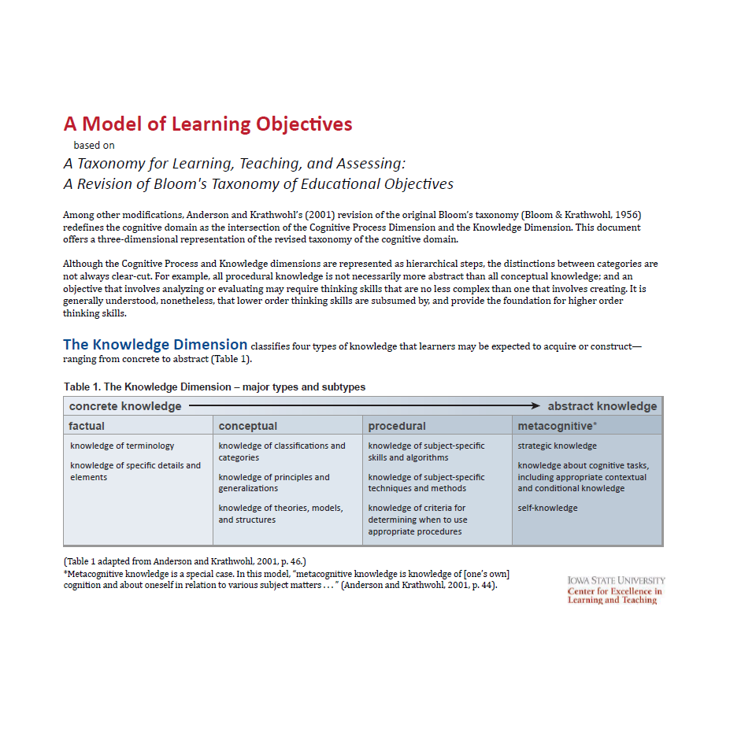

Evaluating Student Learning Outcomes

[Courtesy of http://cstl.semo.edu/SLO/SLOWriting.htm]

We can evaluate a student learning outcome by asking two simple questions:

“Can it be measured?” and “Is learning demonstrated?”
- Take a look at the following examples: Participants will understand the nine reasons for conducting a needs assessment. (Learning is demonstrated, but this student learning outcome will be difficult to measure.)
- Student will arrive on time daily (This can be easily measured, but learning is not necessarily being demonstrated

Upon successful completion of this course, students should be able to:

ART:
Good:
- articulate the role art plays in society using a written critique of an art work,

- identify the connection of historical or current events, which contextualize the making of an artwork.
- identify the formal elements and principles of art, which apply to the creation, and discussion of an artwork,
Poor:
- Students will appreciate art.
- Students will learn how to discuss a work of art.
- Students will be familiar with culture and the relationship of art making.

BIOLOGY:
Good:
- list enzymes involved in DNA replication and explain their roles,
- apply principles of scientific inquiry, differentiate a theory from a hypothesis, and differentiate fact from opinion in regard to biological sciences. (Laney College)
Poor:
- Students will understand the process of DNA replication.
- Students will know the scientific process.
ENGINEERING:
Good:
- apply and demonstrate the principles of engineering design, formulating requirements and constraints, following an open-ended decision process involving tradeoffs, and completing a design addressing an aerospace engineering need. (Southern Polytechnic St. U.)
Poor:
- Students completing the undergraduate program in Hypothetical Engineering will have knowledge of engineering principles. (Southern Polytechnic St. U.)
ENGLISH:
Good:
- demonstrate the ability to communicate effectively in both oral and written forms.
(Univ. of Toledo)
Poor:
- Students will learn how to effectively communicate in both oral and written forms. (Univ. of Toledo)

GEOSCIENCES:
Good:
- interpret unfamiliar tectonic settings based on information on physiography, seismicity, and volcanic activity.(from Barbara Tewksbury’s “Designing Effective and Innovative Courses” tutorial)
Poor:
- Students will understand plate tectonics. (from
Barbara Tewksbury’s Designing Effective and Innovative Courses Tutorial.)
HISTORY:
Good:
- give examples of, describe, and explain significant trends, movements, and events in European history;
- compare and contrast historical perspectives of our world and describe the contributions of these historical perspectives. (Univ. of Toledo)
Poor:
- Students should be able to understand significant trends, movements, and events in European history.
This course will provide learners with an overview of historical perspectives of our world and help them develop an appreciation for the contribution of these various perspectives.
(Univ. of Toledo)

PSYCHOLOGY:
Good:
- recognize and articulate the foundational assumptions, central ideas, and dominant criticisms of the psychoanalytic, Gestalt, behaviorist, humanistic, and cognitive approaches to psychology. (UCF)
Poor:
- Students should know the historically important systems of psychology. (UCF)

The following page contains more examples of student learning outcomes together with a more detailed analysis.

An example of Review Panel feedback
We anticipate much Review Panel feedback will address the SLO component of the outline. Review panels will examine if the SLOs are measurable and if learning is demonstrated by the SLO.
Upon successful completion of this course, students should be able to:

- improve their ability to read, listen to, and/or follow directions,
- Understand the Scientific method
in order to evaluate Koch’s Postulates.
- write papers that:
- develop a thesis
- present coherent and logical claims,
- are organized with clear links between
claims and support,
- are well developed with sufficient and
relevant evidence,
- use standard American English correctly,
- makes stylistic choices in persona,
syntax, and diction: and
- gage the needs of and address a specific
audience.

- demonstrate knowledge of disabilities
and accommodations and services
available for students in the DSP& S
program.
- demonstrate social responsible.

- It is hard to measure “improve” without pre and post testing.

- Are the students only going to listen OR
follow directions?

- The whole concept is vague and unclear, what must the students do?

- What criteria would be used for this?
- While we would all like to see this in our courses, is it an overarching outcome for any other than basic skills courses?
- This SLO has jargon and hidden expectations.
- The SLO could be rewritten to read:
Design experiments and interpret data according to the scientific method in order to evaluate a hypothesis.

- This is specific but some of the language is unclear.
- What is Standard American English?
- Good measureable outcome criteria.
- Clear directions for the students.

- Measureable be could be written with more specific expectations.
- What are the criteria?

- Too general, no way to measure outcomes.
- What does this mean anyway?

http://www.morningside.edu/academics/research/assessment/documents/Writingstudentlearningoutcomes.pdf

Student Learning Outcome Checklist | Yes | No
Do the SLOs include active verbs?
Do the SLOs suggest or identify an assessment?
Do the SLOs address the expected level of learning for the course using Bloom’s Taxonomy as a guideline?
Do the SLOs address more than one domain (cognitive, psychomotor, and affective)? If yes, consider creating multiple SLOs.
Are the SLOs written as outcomes rather than as objectives?
- Language indicates an important overarching concept versus small lesson or chapter objectives.
- Outcomes address what a student will be able to do at the completion of the course.
- SLOs address student competency rather than content coverage.
Are the SLOs appropriate for the course?
- Consistent with the curriculum document of record
- Represents a fundamental result of the course
- Aligns with other courses in a sequence, if applicable
- Represents collegiate level work
Will students understand the SLOs?
Comments or suggestions:
By K. Pluta, J. Fulks, & C. Romanowich
As you revise/review SLOs, keep these things in mind:
-Each course and classroom has unique factors.
-Disciplines have unique language and culture.
-Cross disciplinary conversations are invaluable.
-Ultimately discipline-specific conversations best define competencies for students.
-Everyone is a learner when it comes to assessment.
-As professionals, we are guided by the principles of academic freedom.

A worksheet for Student Learning Outcome generation:
If you need help in getting started
As the expert in your discipline and course, begin by thinking about the 5-7 most important things a student should leave your class being able to DO. Five to seven may not seem like enough, as you may have 20-50 objectives for a course — but these represent the 5-7 things you will assess.
- Spend 15 minutes brainstorming; write down words that express knowledge, skills, or values that integrate the most important aspects of your class.
- BRAINSTORM: In the spaces below, briefly list words or descriptions of 1) attitudes, 2) skills, and/or 3) knowledge that you would like your students to know or do as a result of this course or student services program.
- Attitudes or values developed as a result of this course:
_________________________________________________________________________________________________________________________ _________________________________________________________________________________________________________________________ _________________________________________________________________________________________________________________________
- Skills or performance ability as a result of this course:
_________________________________________________________________________________________________________________________ _________________________________________________________________________________________________________________________ _________________________________________________________________________________________________________________________
- Knowledge and concepts they will have as a result of this course:
________________________________________________________________________________________________________________________ _________________________________________________________________________________________________________________________ _________________________________________________________________________________________________________________________
- Use active verbs and the domain charts to craft sentences that are clear and assessable (measurable).
- Use the checklist to compare your student learning outcomes to some criteria.
- Share these draft student learning outcomes with other faculty to sharpen the focus.

Frequently Asked Questions:
How do the Student Learning Outcomes impact the Class Syllabus?

The submission of a course syllabus is not part of the outline revision or new course approval process. Furthermore, if more than one instructor is to teach a course, a given outline might generate more than one syllabus.
The purpose of the class syllabus is to clearly describe the content and operation of the class so the instructor and students have a mutual understanding of performance expectations and learning outcomes. The syllabus describes what goes on in your classroom. Since the SLOs are included in and describe what the students will learn in the class and how they demonstrate their learning, it is likely that aspects of the SLOs will show up in the syllabus.

For example, since student learning outcomes are expressed with concrete action verbs indicating precisely what is expected of students in measurable terms, this information could be included in the grading methods section of the syllabus. Since relevant skills/knowledge are specified, and assignments, assessments/key course activities (discussion or labs sections) are connected (aligned) to the outcomes, the “journey” through your course can be made clearer to students.
Course outline revision is a great opportunity to improve communication between you and your students through creating a more informative syllabus. The syllabus can and should communicate information about the observable factors (demonstrable skills or actions), the conditions under which students will perform the skill or action, and the criteria that has been established for measuring the quality of the performance. The syllabus might also include the activities/assignments that lead or contribute to the student being able to demonstrate that learning has taken place.
Look critically at whether your existing syllabus explicitly aligns student learning outcomes, required texts/reading (course content), and the way you measure student learning — what students do (activities/assignments) and your assessment of what they do (tests and other assessments). More specifically, how will changes you make to your student learning outcomes affect such syllabus elements as these:
- grading methods,
- schedule of tests and their relation to the overall grade,
- other student performance standards, and
- required texts or readings?
Clear and explicit alignment of outcomes, activities and assessments will help improve student learning as students will have a much better idea, at the start of the course, what is expected of them.

